PRELAB:
Write the code for section 1 and section 2. You will test the code in lab. Read the sections on state machines, entry and exit conditions and the switch case statement.

What is this lab about ?
- A review of state machine structure:
  - Input scan and signal conditioning
  - State entry housekeeping
  - State business
  - State exit housekeeping
  - State transition
- Reading a printed circuit board schematic to identify which microcontroller pins need to be configured as inputs or outputs.
- Writing code to configure microcontroller pins.
- Creating code to perform serial data output and clocking of data into a serial to parallel shift register.

How to Succeed With This Lab:
Refer back to the previous lab handout for sample code. Utilize the Arduino.cc website for reference information on Arduino pin definitions and language.
The number one problem students face doing this lab:
Making the conceptual connection between what a D-flipflop logic gate needs for its D input and its clock input and then understanding how to write a few lines of code so that the microcontroller provides the D input and the clock input to the shift register.
SECTION 1 – Reading a schematic to identify input and output pins of the microcontroller.
Procedure:

- Carefully examine the schematic of the printed circuit board. Note the location and connection of resistors, switches, LEDs, and the shift-register chip. Note the rows of header connectors (J) and note name tags (e.g. D11) are used to indicate a connection between components on the board. Notice how there are two 8 pin headers and two 6 pins headers. Notice which pins are analog pins and which pins are digital.

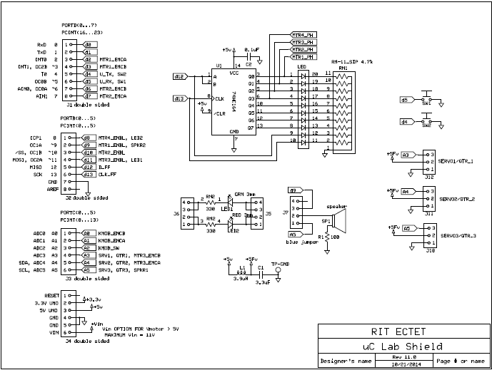
- Review the datasheet pages (next section) for the serial-input, parallel output shift register (74 LS164, or 74 HCT164). Identify what signals on the chip are inputs, which are outputs. Note how the Q pins are connected to the LEDs.
- Write down a list of the microcontroller pins that will be needed to control the 74LS164 shift register. (class activity)
- Write a simple Arduino program to configure the shift register CLOCK and SERIAL_DATA_AB pins and the SW1 and SW2 pins as inputs, input_pullups, or outputs as appropriate. Define the pin’s numbers using #defines and name each pin so that it ends with “_PIN”. Write code so that when SW1 is held pressed down, the SERIAL_DATA_AB pin goes HIGH, and so that when SW2 is held pressed down, the CLOCK pin goes high. Try running your code and observing how the pressing SW1 and SW2 affect the LEDs on the LED bar graph display.

#define SW_PIN 5
// declare variables here

void setup() {
Serial.begin(9600);
Serial.println(F("Lab 3: single LED in motion"));
} // setup()

void loop() {
} // loop()

//****************************************************************************
void functionCall(void) {
}

- Refer to the Timing Diagram and the expanded Logic Diagram in the datasheet on the following pages.
  - Draw a logic timing diagram showing the CLOCK, the SERIAL DATA line, and the QA output for the following scenario:
Start with the SERIAL DATA line LOW. Show the timing diagram and logic levels required to push a value of 1 (HIGH) from the D-input of the very first D-flipflop to the QA output of the very first D-flipflop of the shift register.
Your Timing Diagram

SERIAL DATA (D) ………………………………………………………………………..

CLOCK (CLK) ………………………………………………………………………..

QA OUTPUT (Q) ………………………………………………………………………..

- Get a signoff on your timing diagram and your pin definition code from your instructor.

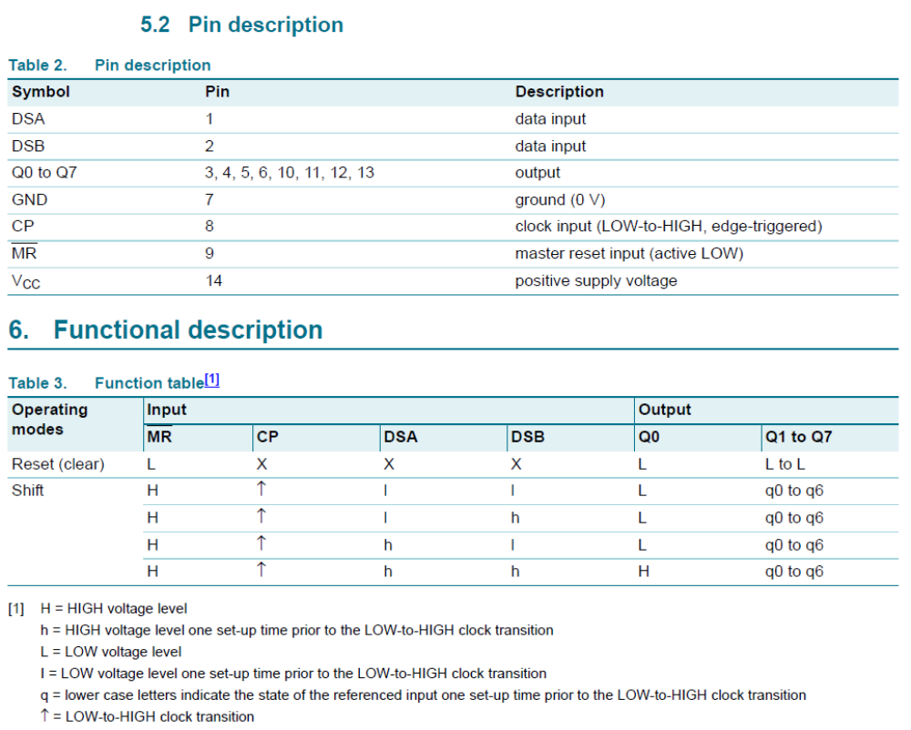
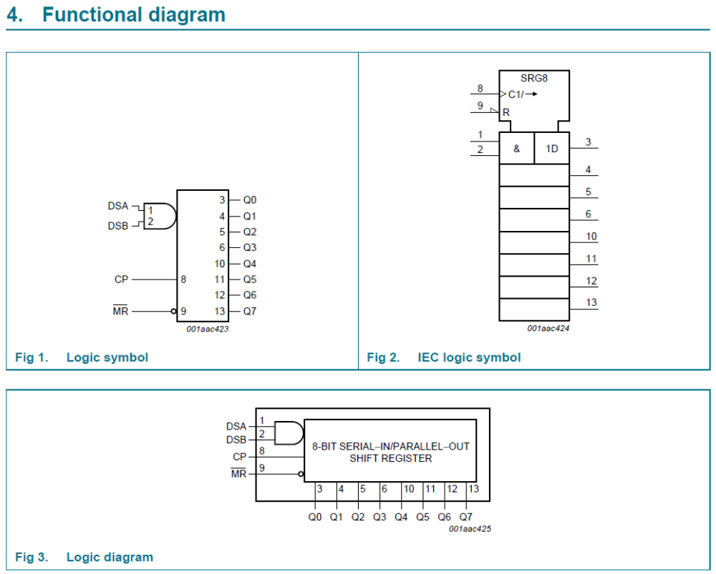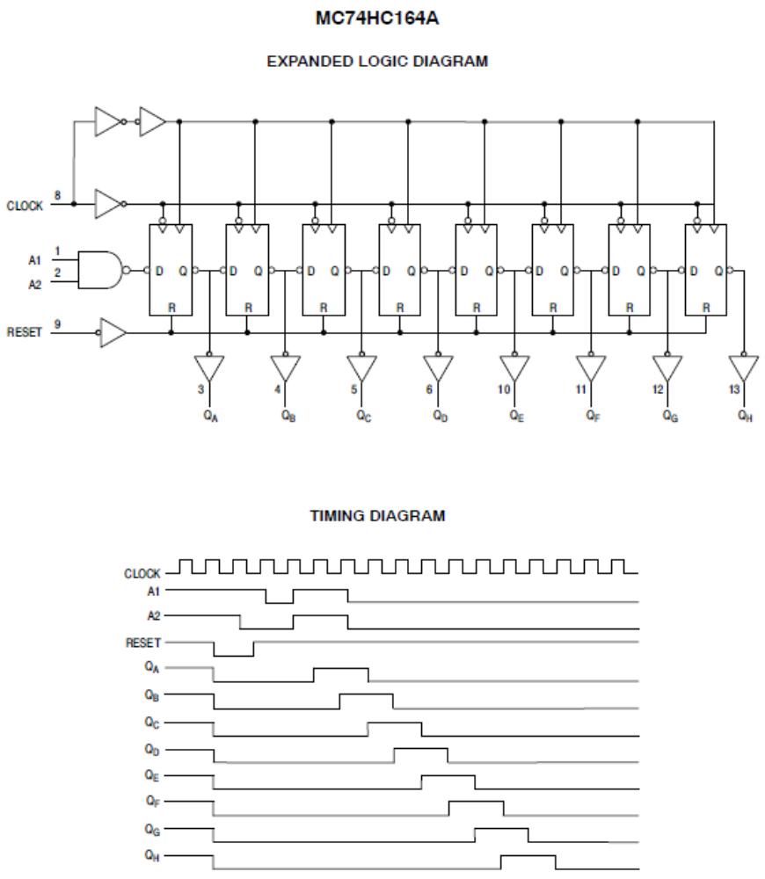

SECTION 2 – Writing code to light the first LED
Procedure:
- Write code to light the first LED of the LED Bar. End your code with a delay(20000) so that you can see what effect the code has.
- Demonstrate your working code to your instructor for a sign off.

SECTION 3 – Writing a function to light the first LED
Procedure:
- Convert your code to function called “lightOneLED” and call that function within the main loop. Again use a delay (20000) so that you can see what effect the code has.
- You may have written your function assuming that the CLOCK and SERIAL DATA lines have a known value before entering the function. Write a short justification for your choice (which ever way you did it in your code).

Written Justification of Your Design Choice:

- I assumed that the CLOCK and SERIAL DATA lines (did / did not) have a known value before entering the function because:

- As opposed to the alternative, I think this is a better way because:

- Demonstrate your working code to your instructor for a sign off.

SECTION 4 – Writing code to push out “barNum” of zeros behind the one LED that is on
Your instructor will demonstrate the “Knight Rider” code that you are to develop. In this code, you will light just one LED bar and have all the other LED’s off. To do this, it will be very helpful to have some code that will say which LED bar number you want to light. The code snippet below will tell you which barNum you want to light. Try serial printing the value of barNum to verify that the code works as expected.

// bar number counts up to 9 and then down to 0 creating a back and forth motion
if (barNum == 9) { // if at the top, change direction -- count down
increment = -1;
}
if (barNum ==0) {// if at the bottom, change direction -- count up
increment = 1;
}
barNum = barNum + increment;
Serial.println(barNum); // for debug

Procedure:
- Insert the barNum code into your code. Serial print the value of barNum and check that it works as expected.
- Write code that pushes out “barNum” worth of zeros behind the one LED that is on
- Demonstrate your working code to your instructor for a sign off.

Tips: Use Serial Print to check the values of barNum, etc. Also, use delay (200) or delay (5000) to slow down the system for debugging.

SECTION 5 – Writing code to clear shift register and turn off all LEDs.
Procedure:
- Write code that pushes out 8 zeros to the shift register, turning off all LEDs on the shift register.
- Demonstrate your working code to your instructor for a sign off.

SECTION 6 – Convert your code to function that turn off all LEDs.
Procedure:
- Write a function called “turnOffAllLEDs” that pushes out 8 zeros to the shift register and turns off all the LEDs.
- When you test your function you may notice that two LEDs do not turn off. You will need to add some additional code as a special case to turn off these LEDs. Refer to the printed circuit board schematic to figure out how to turn off these LEDs.
- Demonstrate your working code to your instructor for a sign off.

SECTION 7 – Writing code that creates the knight rider effect.
Procedure:
- Demonstrate your working code to your instructor for a sign off.

Write Up:
There is no write up for this lab, just get the items on the cover sheet (next page) signed off by your lab instructor and submit just the cover sheet in class.
Date: ______________________

Names: ______________________

Section: ______________________

LABORATORY CHECK OFFS
Section 1  - Timing Diagram showing CLK, SERIALDATA, QA output  - Code for configuring pins as inputs and outputs in setup()  Section 2  Code to clock one data value of 1 (HIGH) into shift register  Section 3  - Function to clock one data value of 1 (HIGH) into shift register  - Written justification completed  Section 4  - Serial print of barNum shows correct values  - Code to push out barNum zeros behind the one  Section 5  Code to clear out shift register (set all LEDs off)  Section 6  Function to clear out shift register (set all LEDs off)  Section 7  Knight Rider – single LED bar sweeps across display | ____  ____  ____  ____  ____  ____  ____
Points | ____

